**Manging Log files:**

STEP-1:Docker Logs

When you start a container, Docker will track the Standard Out and Standard Error outputs from the process and make them available via the client.

Example: In the background, there is an instance of Redis running with the name redis-server. Using the Docker client, we can access the standard out and standard error outputs using docker logs redis-server

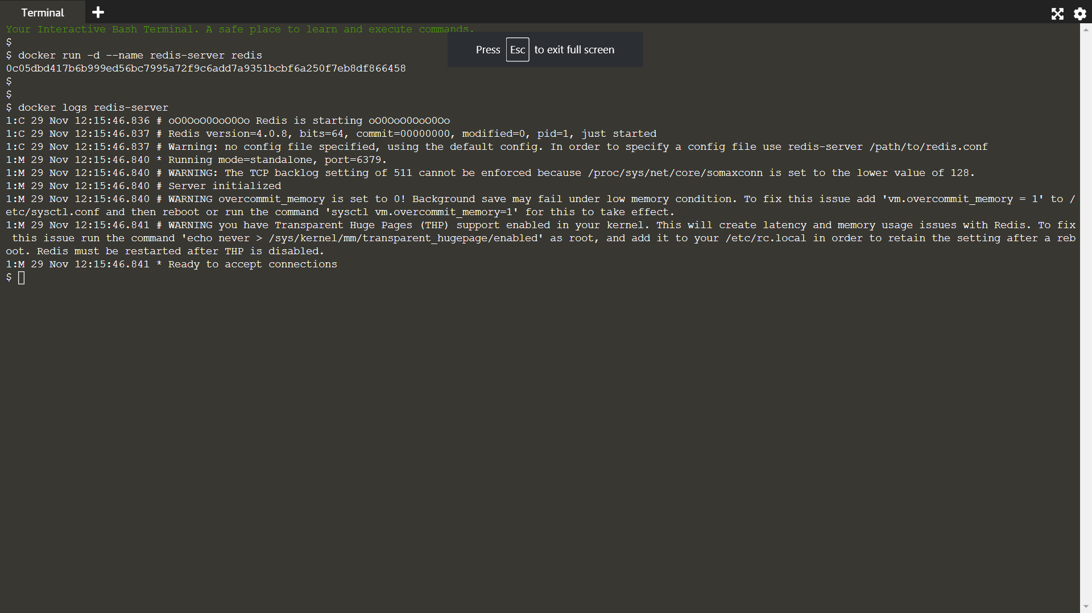

STEP-2:SYS LOG

By default, the Docker logs are outputting using the json-file logger meaning the output stored in a JSON file on the host. This can result in large files filling the disk. As a result, you can change the log driver to move to a different destination

Syslog

The Syslog log driver will write all the container logs to the central syslog on the host. "syslog is a widely used standard for message logging. It permits separation of the software that generates messages, the system that stores them, and the software that reports and analyses them."

Example:

docker run -d --name redis-syslog --log-driver=syslog redis

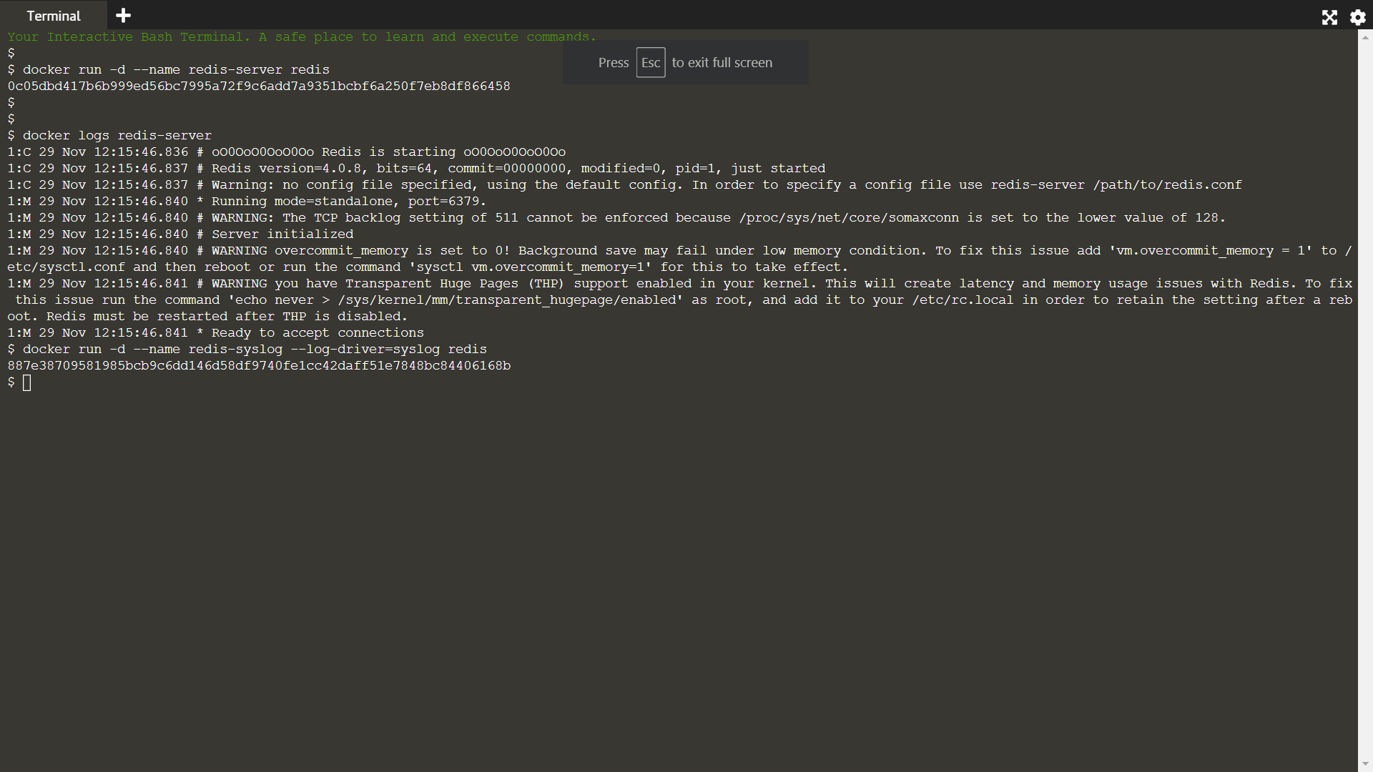

Acessing Logs:

If you attempted to view the logs using the client you'll recieve the error FATA[0000] "logs" command is supported only for "json-file" logging driver

STEP-3:Disable logging

The third option is to disable logging on the container. This is particularly useful for containers which are very verbose in their logging

Example

When the container is launched simply set the log-driver to none. No output will be logged.

docker run -d --name redis-none --log-driver=none redis

Which config?

The inspect command allows you to identify the logging configuration for a particular container. The command below will output the LogConfig section for each of the containers.

Server created in step 1

docker inspect --format '{{ .HostConfig.LogConfig }}' redis-server

Server created in step 2

docker inspect --format '{{ .HostConfig.LogConfig }}' redis-syslog

Server created in this step

docker inspect --format '{{ .HostConfig.LogConfig }}' redis-none